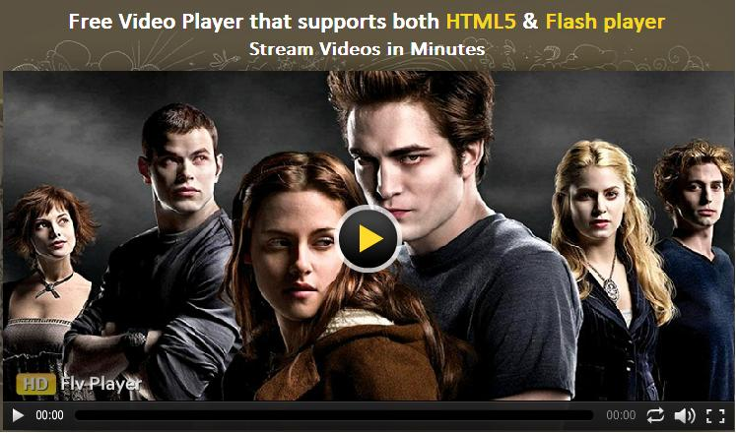

C:\Documents and Settings\user.USER-98A632EC14\Desktop\img\hd_logo1.png

Product version: 4.0

**User Manual**

Now integrating a video player on your website is absolutely easy with our HD FLV Player 4.0. Our HD FLV Player allows you to play and watch popular video formats such as MP4, M4V, M4A, MOV, MP4v, and F4V from different video sharing communities like YouTube, Daily Motion, and Viddler with absolute ease. With some salient features like HTML support to play videos in iPhones & iPads, Lighttpd & RTMP streaming, Monetization, Native language support, and Social Bookmarking, the player promises to be ultimately unique and best fit to any website.

**Table of Contents**

**Preface ………………………………………………………………………………………………..……4**

* About This Document ………………………………………………………………………………………………….4
* Updates, Comments, and Suggestions ………..………………………………………………….……….4

* Disclaimer ……………..…………………………………………………………………………………………………...4

**HD FLV Player Features ……………………………………………………………………………...5**

* Streaming Videos…..………………..………………………………………………………………………………….5
* HTML5…………………………………………………………..………………………………………………………………5
* Branding & Ownership ……………………………………………………………………………………..……….5
* Full Control on Your Player …………………………….…..……………………………………………..……..5
* Monetize……………………………..……………………………………………………………………………………....5
* Native Language……………………………………………………………………………………………………..…..5
* Stylish Skin ………………………………………………………………………………………………………………….5
* Streaming from Video Sharing Community……………………..……………….……………………..5
* Embed Videos…………………………………..……………………………………………………………..………….5

* Bookmarking…………………………………………....………..………………………………………………………5

* Tool Tip……………………………………………………..……………………..……………….……..…………….….6
* Google Analytics……………………………..……………………………………………………….…………..…….6

**Installation Steps ……………………………………………………………………………………..6**

**HD FLV Player XML…………………………………………………………………………….…..….7**

* Player Configuration…..……………………………………………………………………………..…….………….7
* Playlist Configuration………………………………………………………………………………………..…………11
* Language Configuration………………………………………………………………………………..……..…….13

* Ads Configuration ………………………………………………..………………….………………....….………..13
* Google Interactive Ads (IMA)…………………………………………………………………………….…..….14
* Mid-roll Ads Configuration...……………………………………………………………………………………….15
* Example Codes Video Configuration ……………………………………………..…………..………….…16
* Example Codes YouTube/Daily Motion/Viddler Video………………………….…..….……..……17
* Example Codes Pre-roll/Post-roll/Mid-roll ads………..………..………………….……………………18
* Example Codes RTMP Server Video..…………..……………………………………………………….……20
* Example Codes Lighttpd/Pesudostreaming .………..………………………..………………..………21

**HD FLV Player Flashvar .……………………………………………………………….………….22**

* Player Configuration ………………………….…………………………………………………………………….22
* Video Configuration ……………………………………………………………………………………………..….23
* Ads Configuration…………………………...……………………………………………………………………….24
* Example Codes RTMP Server Video……………………………………………….………………………26
* Example Codes Lighttpd/Pesudostreaming.……………………………………..………………..…27
* Example Codes YouTube/Daily Motion/Viddler Video …………………….………………….…28

**HD FLV Player HTML5………………………………………………………………………….....29**

**HD FLV Player Source……………………………………………………………………….…....30**

* Using source code …………………………………………………………………………………………..………30
* Player customization……………………………………………………………………………………..…….….30
* Skin customization…………………………………………………………………………….………..…………..30

**Contact Us ……………………………………………………………………………………………..31**

Preface



**About This Document**

This document provides information on how to download source codes, install, configure, and use our open source HD FLV Player.

**Updates, Comments, and Suggestions**

Please forward your valuable comments, suggestions, or questions about the information contained in this document to [assist@apptha.com](mailto:assist@apptha.com).

If you have a new question, please add it to the forum so that our special pool of talents may help you with relevant answers. You can add your query on any of the two below links.

<http://www.hdflvplayer.net/forum/viewforum.php?f=39&sid=af0c387065d5a2d159d092eda720630b>

<http://www.apptha.com/forum/viewforum.php?f=130&sid=2f050902f54e7fd1b84ffd85aa7b2296>

<https://github.com/Apptha/hdflvplayer/issues>

**Disclaimer**

HD FLV Player reserves the right to add, remove, or modify any features or processes related to packaging, selling, and marketing of the player, at any time and without prior notification.

HD FLV Player reserves the right to add new features to its products based on research and market needs.

HD FLV Player reserves the right to remove any feature of its products that does not fulfill expectations.

HD FLV Player Features



**Streaming Videos:**

Supports streaming video formats like Lighttpd, RTMP, Live Telecast, Amazon S3, Pseudostreaming.

**HTML5:**

Supports HTML5 and flash from web and smartphones to help you relish high-quality videos.

**Branding & Ownership:**

Assists in adding your own logo to player by right clicking copyrights (however with license permission provided by us) and allows you to set your logo on top-right, top-left, bottom-right, and bottom-left.

**Full control on your player:**

Provides you with complete option to enable/disable the following parameters of the player: Share button, Volume button, Download button, Email button, playlist Autoplay button, Progress bar in skin, Fullscreen, Timer, Zoom, Playlist, default playlist open/close.

**Monetize:**

Facilitates you with options to monetize using Pre-, Mid-, Post-roll videos/texts, and IMA ads.

**Native Language:**

Provides you option to set the language settings to display your native langauge text on the player.

**Stylish Skin:**

Enthralls you with a stylish and impressive skin from which you can set your own color based on your website style.

**Streaming from Video Sharing Community:**

Facilitates you with option to play videos directly from YouTube, Daily Motion, Viddler.

**Embed Videos:**

Powers you with an option to embed videos on other websites upon clicking the Share button.

**Bookmarking:**

Provides you with an option to share your videos via 4 social networking sites like Facebook, Twitter, Google+, and Tumblr.

**Tool Tip:**

Powers you with Tool Tip button which can be set to your native language as well.

**Google Analytics:**

Facilitates you with Google Analytics interface to track the flash-driven content easily.

Installation Steps

1. Extract the downloaded zip-file to your local directory.

**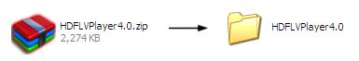**

2. Open HD FLV Player .

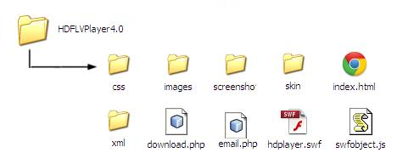

3. Run the index file in a browser

­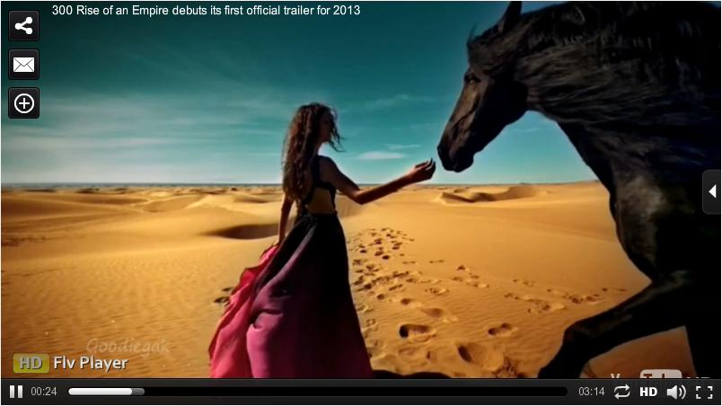

(Fig 1.1) Player View

4. You have successfully installed HD FLV Player.

HD FLV Player XML

Find the following XML files that we have incorporated on the player to perform multiple actions based on your preferences.

**Player Configuration**

1. Open Hd Flv Player – xml – config.xml in text editor (Notepad, Wordpad, etc.)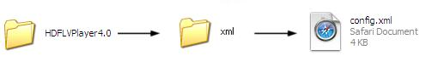

2. Find the following variables to configure the player.

|  |  |  |  |
| --- | --- | --- | --- |
| S. No. | Variables | Value | Process |
|  | Stagecolor | Hexa-decimal value (0xFFFFFF) | Changes the color of player background. |
|  | Autoplay | True “or” false | 1. If set “true” starts playing the video when page gets loaded (without user mouse event). 2. If set “false” waits for the user’s mouse event to play the video. |
|  | Buffer | 0–10  (recommended = 3) | Controls the buffer seconds. |
|  | Volume | 0–100 | Controls the initial volume level. |
|  | Normalscale | 0, 1, 2  0–Aspect ratio  1–Keep original size  2–Fit to screen | Controls the scaling of video in Normal screen mode. |
|  | Fullscreenscale | 0, 1, 2  0–Aspect ratio  1–Keep original size  2–Fit to screen | Controls the scaling of video in Full screen mode. |
|  | License | License key provided by us for the commercial version. | Could use own logo with copyright permission. |
|  | Logopath | Absolute path of your logo (works only in commercial version) | Passes the logo path. (Allowed extensions: jpg, png, gif, swf) |
|  | Logoalpha | 0–100 (works only in commercial version) | Controls the alpha transparency of Logo. |
|  | Logoalign | TL–Top-left alignment TR–Top-right alignment BR–Bottom-right alignment BL–Bottom-left alignment (works only in commercial version) | Controls the logo alignment. |
|  | logo\_target | Absolute path (Works only in commercial version) | Redirects to Target Page on clicking the Logo. |
|  | Skin | Absolute path | Uses the provided skin from skin folder. |
|  | skin\_autohide | True “or” false | Uses the skin auto hide option. |
|  | skinBgColor | Hexa-decimal value (0×333333) | Changes the color of player’s skin background. |
|  | seek\_barColor | Hexa-decimal value (0xFFFFFF) | Changes the color of player’s skin seek\_bar color. |
|  | buffer\_barColor | Hexa-decimal value (0×999999) | Changes the color of player’s skin buffer\_bar color. |
|  | pro\_BgColor | Hexa-decimal value (0×000000) | Changes the color of player’s skin progress bar background color. |
|  | skinIconColor | Hexa-decimal value (0xFCFCFC) | Changes the color of player’s skin icon color. |
|  | languageXML | Absolute path | XML file that converts your player to your native language. |
|  | playlistXML | Absolute path | XML file that contains the videos Information (will be explained below). |
|  | relatedVideoView | Side “or” Center | Displays Related Video planers either at the center or right side of the player. |
|  | showPlaylist | True “or” false | Shows/Hides the playlist thumbnails. |
|  | playlist\_open | True “or” false | Opens Related Video thumbnails when video loads. |
|  | relatedVideoBgColor | Hexa-decimal value (0×000000) | Changes the color of player-related video panel background. |
|  | scroll\_barColor | Hexa-decimal value (0xFFFFFF) | Changes the color of player-related video scroll\_bar color. |
|  | scroll\_BgColor | Hexa-decimal value (0×000000) | Changes the color of player-related video scroll\_bar background color. |
|  | scroll\_BgColor | Hexa-decimal value (0×000000) | Changes the color of player-related video scroll\_bar background color. |
|  | playButtonColor | Hexa-decimal value (0xFFFFFF) | Changes the color of player’s Play button color. |
|  | playButtonBgColor | Hexa-decimal value (0xFFFFFF) | Changes the color of player’s Play button background color. |
|  | HD\_default | True “or” false | Makes playing the HD videos in default if both HD and normal videos provided to the player. |
|  | adXML | Absolute path | XML file that contains self created pre- and post-roll ads to be played along with videos. |
|  | preroll\_ads | True “or” false | Global control to enable/disable pre-roll ads. |
|  | postroll\_ads | True “or” false | Global control to enable/disable post-roll ads. |
|  | midrollXML | Absolute path | XML file that contains self created mid-roll ads to be played for the videos. |
|  | midroll\_ads | True “or” false | Global control to enable/disable mid-roll ads. |
|  | adsSkip | True “or” false | Shows/Hides the pre-roll or post-roll Ads Skip button player. |
|  | adsSkipDuration | Numerical value represented in seconds | Shows/Hides the pre-roll or post-roll Ads Skip  button player. |
|  | imaAds | True “or” false | Global control to enable or disable IMA ads. |
|  | shareURL | Absolute path | File that contains server side script to Send mail. |
|  | embed\_visible | True “or” false | Enables/disables the Embed option. |
|  | Download | True “or” false | Global control to enable/disable Download button in player. |
|  | downloadUrl | Absolute path | File that contains server side script to download videos. |
|  | trackCode | Tracking code | The form trackCode UA-XXXXX-Y or UA-XXXXX-YY. |
|  | showTag | True “or” false | Shows/Hides the video description on top of player. |
|  | textColor | Hexa-decimal value (0xFFFFFF) | Changes the color of player’s default text. |
|  | sharepanel\_up\_BgColor | Hexa-decimal value (0×000000) | Changes the color of player’s share panel up background color. |
|  | sharepanel\_down\_BgColor | Hexa-decimal value (0×000000) | Changes the color of player share panel down background color. |
|  | sharepaneltextColor | Hexa-decimal value (0×000000) | Changes the color of player share panel text color. |
|  | sendButtonColor | Hexa-decimal value (0×000000) | Changes the color of player Mail Send button . |
|  | sendButtonTextColor | Hexa-decimal value (0×000000) | Changes the color of player Mail Send button text color. |
|  | imageDefault | True “or” false | Shows/Hides to display default images in player. |
|  | Timer | True “or” false | Shows/Hides the Timer button in skin. |
|  | zoomIcon | True “or” false | Shows/Hides the Zoom button in top-left of the player. |
|  | Email | True “or” false | Shows/Hides the Email button in top-left of the player. |
|  | shareIcon | True “or” false | Shows or hides the Share button in top-left of the player. |
|  | fullscreen | True “or” false | Shows/Hides the Full Screen button in skin. |
|  | Volumecontrol | True “or” false | Shows/Hides the Volume Control button in skin. |
|  | progressControl | True “or” false | Shows/Hides the Progress bar in skin. |
|  | skinVisible | True “or” false | Shows/Hides the skin of player. |

**Playlist Configuration:**

1. Open Hd Flv Player – xml – playlist.xml in text editor (Notepad, Wordpad etc.)

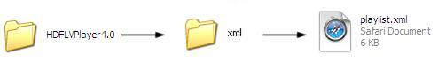 

(Fig 1.2) Playlist View

2. You will be able to find the following attributes in playlist.

|  |  |  |  |
| --- | --- | --- | --- |
| S. No. | Variables | Value | Process |
|  | autoplay | True “or” false | Player plays the videos  In loop. |
|  | Random | True “or” false | If set “True” player starts playing videos randomly. |
|  | video\_url | Absolute path of the video | Facilitates with option to set Non-HD video file. |
|  | video\_hdpath | Absolute path of the video | Facilitates with option to set HD video file. |
|  | Id | Unique video id | This variable helps to share videos. |
|  | thumb\_image | Absolute path | Displays related video list in Thumbnails. |
|  | preview\_image | Absolute path | Displays Preview image before Video plays and after video ends. |
|  | allow\_preroll | True “or” false | If set “True” pre-roll ad video will be displayed for this video. |
|  | preroll\_id | Unique pre-roll id. | To get pre-roll data from Ads xml. |
|  | allow\_midroll | True “or” false | If set “True” mid-roll ad will be displayed for this video. |
|  | allow\_postroll | True “or” false | If set “True” post-roll ad video will be displayed for this video. |
|  | postroll\_id | Unique post-roll id | To get post-roll data from Ads xml. |
|  | allow\_download | True “or” false | Enables/disables Download button in share part, where the viewers can download the Playing video. |
|  | streamer\_path | Streamer path | Applicable only if the videos are from Streaming servers. |
|  | Copylink | Absolute Path | Video URL path (optional). |
|  | video\_isLive | True “or” false | If set “True” plays the live stream Videos with options to control live videos. |
| **<title><![CDATA[Video Title]]></title>** Title of the video. | | | |
| <tagline targeturl=”https://mydomain.com”><![CDATA[**Video Description** ]]> </tagline> | | | |

**Language Configuration:**

1. Open Hd Flv Player – xml – language.xml

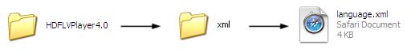

2. You will be able to find the tags in the following format:

**Example:** <play> <![CDATA[Play]]> </play>

Just change the text “Play” to your native language and run it in your browser. You will be finding the text of Play changed to your language preference.

Thus, you can change all the provided tags to your native language.

**Ads Configuration**

1. Open HD FLV Player – xml – ads.xml.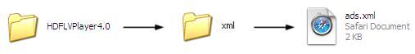



(Fig 1.3) Pre-roll/Post-roll ads View

2. XML attributes to help you play pre- and post-roll ads on the player.

|  |  |  |  |
| --- | --- | --- | --- |
| S. No. | Variables | Value | Process |
|  | Random | True “or” false | If set “True” plays the ads randomly from ads XML file. |
|  | Id | Your ads video id goes here | Used to identify ads |
|  | Url | Absolute path of ad video | This url video play as ads |
|  | Targeturl | Absolute path | Redirects to target page on clicking the ad. |
|  | Clickurl | Unique video id | A php file that counts the ad clicks **(optional).** |
|  | Impressionurl | Absolute path | A php file that counts the ad clicks **(optional).** |

**Google Interactive Ads(IMA)**

1. Open HD FLV Player – xml – ima.xml.

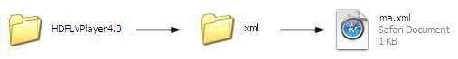

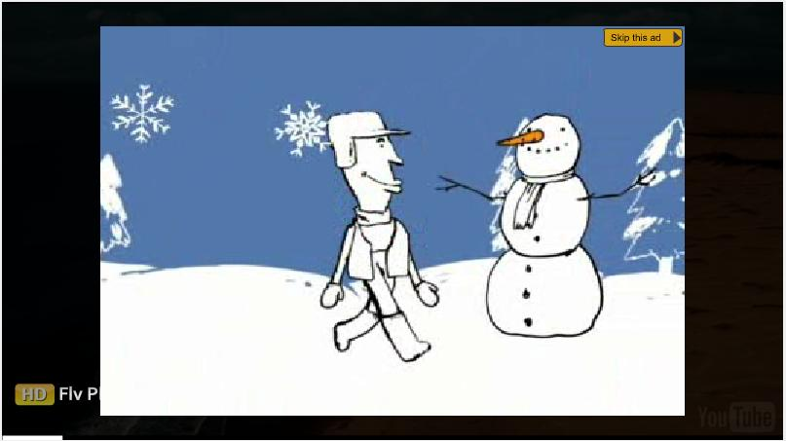

(Fig 1.4) Google Interactive Ads (IMA) View

2. XML attributes to help you play Google Interactive Media Ads (IMA) on player.

|  |  |  |  |
| --- | --- | --- | --- |
| S. No. | Variables | Value | Process |
|  | adSlotWidth | Number | The width/height of the player or area you want your ads to fill. |
|  | adTagUrl | XML path | Specifies full URL to use for ads loading from DoubleClick ad server. |
|  | publisherId | Provided by AdSense | The AFV publisher's client ID. |
|  | contented | Number | Specifies the publisher's unique identifier for content. |
|  | adType | Text /Video/Overlay | By default adType is video. However, provides option to modify adType to text or overlay. |
|  | Channels | Array | An array of strings representing AdSense targeting/reporting channel IDs. |

**Mid-roll Ads Configuration**

1. Open HD FLV Player – xml – midroll.xml.

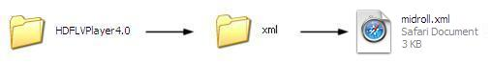

2. XML attributes to help you show mid-roll ads.

|  |  |  |  |
| --- | --- | --- | --- |
| S. No. | Variables | Value | Process |
|  | begin | Numerical value represented in seconds | Time to start displaying mid-roll ad. |
|  | adrotate | True “or” false | Displays all ads available in ads xml in Rotation. |
|  | random | True “or” false | Displays mid-roll ads in random. |
|  | adinterval | Absolute path | A php file that counts the ad impressions (**optional).** |
|  | targeturl | Absolute path | A php file that counts the ad clicks (**optional).** |
|  | clickurl | Array | An array of strings representing AdSense targeting/reporting channel IDs |
|  | impressionurl | Absolute path | A php file that counts the ad Impressions (**optional).** |
| **<! [CDATA[Your mid-roll content]]>** A Displaying CSS formatted mid-roll content. | | | |

**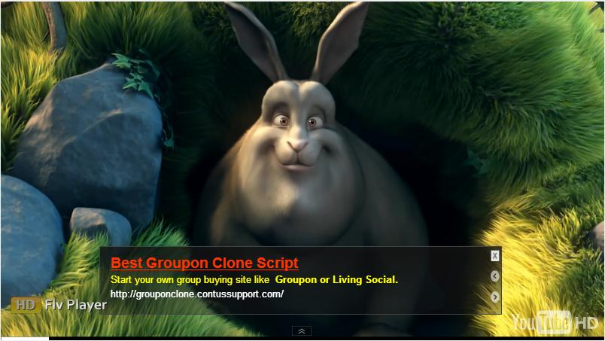**

(Fig 1.5) Mid-roll ads View

**Example Codes Video Configuration**

1. Open config.xml and edit the following attribute and save the file.

playlistXML = “http://yourdomain.com/HD FLV Player /xml/playlist.xml”

showPlaylist = “true”

2. Open playlist.xml and edit the following attributes and save the file.

<playlist autoplay=”false” random=”false”>

<mainvideo

***video\_url="Your stream name goes here"***

**video\_hdpath=""**

**video\_id="** Your video id goes here**"**

**thumb\_image="**Your video thumb image path goes here**"**

**preview\_image="**Your Preview image path goes here**"**

**allow\_preroll="false"**

**allow\_midroll="false"**

**allow\_postroll="false"**

**allow\_ima="true"**

**preroll\_id ="1"**

**postroll\_id ="2"**

**allow\_download="true"**

**copylink=""**

**streamer\_path=""**

**video\_isLive="false" >**

**<title><![CDATA[video\_title]]></title>**

**<!--Optional-->**

<tagline targeturl=”https://mydomain.com”><![CDATA[<spanclass='heading'>Tagline - </span> <b>Your short description goes here for videos.</b>]]</tagline>

</mainvideo>

</playlist>

3. Run index.html in your favorite browser.

**Example Codes Youtube/Daily Motion/Viddler Video**

1. Open config.xml and edit the following attribute and save the file.

playlistXML = “http://yourdomain.com/HD FLV Player /xml/playlist.xml”

showPlaylist = “true”

2. Open playlist.xml and edit the following attributes and save the file.

<playlist autoplay=”false” random=”false”>

<mainvideo

***video\_url=”***Youtube/DailyMotion/Viddler video page url goes here***”>***

**video\_hdpath=""**

**video\_id="**Your video id goes here**"**

**thumb\_image="**Your video thumb image path goes here**"**

**preview\_image="**Your Preview image path goes here**"**

**allow\_preroll="false"**

**allow\_midroll="false"**

**allow\_postroll="false"**

**allow\_ima="true"**

**preroll\_id ="1"**

**postroll\_id ="2"**

**allow\_download="true"**

**copylink=""**

**streamer\_path=""**

**video\_isLive="false" >**

**<title><![CDATA[video\_title]]></title>**

**<!--Optional-->**

<tagline targeturl=”https://mydomain.com”><![CDATA[<spanclass='heading'>Tagline - </span> <b>Your short description goes here for videos.</b>]]</tagline>

</mainvideo>

</playlist>

3. Run index.html in your favorite browser.

**Example Codes Pre-roll/Post-roll/Mid-roll ads**

1). Open config.xml and edit the following attributes and save the file.

playlistXML = "http://yourdomain.com/hdflvplayer/xml/playlist.xml"

showPlaylist = "true"

adXML = "http://yourdomain.com/hdflvplayer/xml/ads.xml"

midrollXML = "http://yourdomain.com/hdflvplayer/xml/midroll.xml"

preroll\_ads = "true"

midroll\_ads = "true"

postroll\_ads = "true"

2). Open playlist.xml and edit the following attributes and save the file.

<playlist autoplay=”false” random=”false”>

<mainvideo

***video\_url="Your stream name goes here"***

**video\_hdpath=""**

**video\_id="**Your video id goes here**"**

**thumb\_image="**Your video thumb image path goes here**"**

**preview\_image="**Your Preview image path goes here**"**

***allow\_preroll="true"***

***allow\_midroll="true"***

***allow\_postroll="true"***

***allow\_ima="true"***

***preroll\_id ="1"***

***postroll\_id ="2"***

**allow\_download="true"**

**copylink=""**

**streamer\_path=""**

**video\_isLive="false" >**

**<title><![CDATA[video\_title]]></title>**

**<!--Optional-->**

<tagline targeturl=”https://mydomain.com”><![CDATA[<spanclass='heading'>Tagline - </span> <b>Your short description goes here for videos.</b>]]</tagline>

</mainvideo>

</playlist>

3). Open ads.xml and edit the following attributes and save the file.

<ads random="false">

<ad url="your ad video here" targeturl="http://www.platoon.in" clickurl="" impressionurl="">

<![CDATA[<spanclass='heading'> Tagline - </span> <b> Your short description goes here for

ad.</b>]]></ad>

</ads>

4). Open midroll.xml and edit the following attributes and save the file.

<midrollad begin="5" adinterval="20" adrotate="true" random="false">

<midroll targeturl="http://www.platoon.in" clickurl=""

impression=""><![CDATA[<spanclass='heading'>Platoon</span><br><span class='midroll'>Platoon is a offshore <b>

Software and Web Development company</b> from India.</span> ]]> </midroll>

</midrollad>

5). Run index.html in your favorite browser.

**Example Codes RTMP Server Video**

1. Open config.xml and edit the following attributes and save the file.

playlistXML = "http://mydomain.com/hdflvplayer/xml/playlist.xml"

showPlaylist = "true"

2. Open playlist.xml and edit the following attributes and save the file.

<playlist autoplay=”false” random=”false”>

<mainvideo

***video\_url=”****Your Stream name goes here***”*>***

**video\_hdpath=""**

**video\_id="**Your video id goes here**"**

**thumb\_image="**Your video thumb image path goes here**"**

**preview\_image="**Your Preview image path goes here**"**

**allow\_preroll="false"**

**allow\_midroll="false"**

**allow\_postroll="false"**

**allow\_ima="true"**

**preroll\_id ="1"**

**postroll\_id ="2"**

**allow\_download="true"**

**copylink=""**

***streamer\_path="*** *rtmp://mydomain.com/application****"***

**video\_isLive="false" >**

**<title><![CDATA[video\_title]]></title>**

**<!--Optional-->**

<tagline targeturl=”https://mydomain.com”><![CDATA[<spanclass='heading'>Tagline - </span> <b>Your short description goes here for videos.</b>]]</tagline>

</mainvideo>

</playlist>

3. Run index.html in your favorite browser.

**Example Codes Lighttpd/Pseudostreaming**

1. Open config.xml and edit the following attributes and save the file.

playlistXML = "http://mydomain.com/hdflvplayer/xml/playlist.xml"

showPlaylist = "true"

2. Open playlist.xml and edit the following attributes and save the file.

<playlist autoplay=”false” random=”false”>

<mainvideo

***video\_url=”****Your Stream name goes here***”*>***

**video\_hdpath=""**

**video\_id="** Your video id goes here**"**

**thumb\_image="**Your video thumb image path goes here**"**

**preview\_image="**Your Preview image path goes here**"**

**allow\_preroll="false"**

**allow\_midroll="false"**

**allow\_postroll="false"**

**allow\_ima="true"**

**preroll\_id ="1"**

**postroll\_id ="2"**

**allow\_download="true"**

**copylink=""**

***streamer\_path*=*"****pseudostreaming****"***

**video\_isLive="false" >**

**<title><![CDATA[video\_title]]></title>**

**<!--Optional-->**

<tagline targeturl=”https://mydomain.com”><![CDATA[<spanclass='heading'>Tagline - </span> <b>Your short description for videos goes here.</b>]]</tagline>

</mainvideo>

</playlist>

3. Run index.html in your favorite browser.

­­­­­HD FLV Player Flashvar

**Player Configuration**

1. Open index.html in your favorite editor.

2. You will be able to find the following code snippet

<div name=’mediaspace’ id=’mediaspace’>

<script type=”text/javascript”>

var s1 = new SWFObject(‘hdplayer.swf’, ‘player’, ’640′, ’360′, ’9′);

s1.addParam(‘allowfullscreen’, ‘true’);

s1.addParam(‘allowscriptaccess’, ‘always’);

s1.addParam(‘wmode’, ‘transparent’);

s1.write(‘mediaspace’);

</script>

3. Add the below line next to s1.addParam (‘wmode’, ‘transparent’);

s1.addVariable (‘stagecolor’, ’0×000000′);

s1.addVariable (‘autoplay’, ‘true’);

s1.addVariable (‘buffer’, ’3′);

s1.addVariable (‘volume’, ’80′);

4. Your final code will look as the following.

<div name=’mediaspace’ id=’mediaspace’>

<script type=”text/javascript”>

var s1 = new SWFObject(‘HD FLV Player /hdplayer.swf’, ‘player’, ’640′, ’360′, ’9′);

s1.addParam(‘allowfullscreen’, ‘true’);

s1.addParam(‘allowscriptaccess’, ‘always’);

s1.addParam(‘wmode’, ‘transparent’);

*s1.addVariable (‘stagecolor’, ’0×000000′);*

*s1.addVariable (‘autoplay’, ‘true’);*

*s1.addVariable (‘buffer’, ’3′);*

*s1.addVariable (‘volume’, ’80′);*

s1.write(‘mediaspace’);

</script>

5. Run index.html in your favorite browser.

**Video Configuration**

1). Open index.html in your favorite editor.

2). You will be able to find the following code snippet.

<div name='mediaspace' id='mediaspace'>

<script type="text/javascript">

var s1 = new SWFObject(hdplayer.swf', 'player', '640', '360', '9');

s1.addParam('allowfullscreen', 'true');

s1.addParam('allowscriptaccess', 'always');

s1.addParam('wmode', 'transparent');

s1.write('mediaspace');

</script>

3). Add the below line next to s1.addParam('wmode', 'transparent');

s1.addVariable('file', 'your video file path goes here');

s1.addVariable('hdpath', 'Your HD file path goes here');

4). Your final code will look as the following.

<div name='mediaspace' id='mediaspace'>

<script type="text/javascript">

var s1 = new SWFObject('hdflvplayer/hdplayer.swf', 'player', '640', '360', '9');

s1.addParam('allowfullscreen', 'true');

s1.addParam('allowscriptaccess', 'always');

s1.addParam('wmode', 'transparent');

*s1.addVariable('file', 'Your video file path goes here');*

*s1.addVariable('hdpath', 'Your HD file path goes here');* -----------------------Optional.

s1.write('mediaspace');

</script>

5) Run index.html in your favorite browser.

**Ads Configuration**

1). Open index.html in your favorite editor.

2). You will be able to find the following code snippet.

<div name='mediaspace' id='mediaspace'>

<script type="text/javascript">

var s1 = new SWFObject('hdplayer.swf', 'player', '640', '360', '9');

s1.addParam('allowfullscreen', 'true');

s1.addParam('allowscriptaccess', 'always');

s1.addParam('wmode', 'transparent');

s1.write('mediaspace');

</script>

3). Add the below line next to s1.addParam('mode', 'transparent');

s1.addVariable('file', 'Your video file path goes here');

s1.addVariable('hdpath', 'Your HD file path goes here');

*s1.addVariable('preroll\_ads', 'true');*

*s1.addVariable('prerollad', 'Your ad video goes here');*

*s1.addVariable('prerolltrageturl', 'your ad sponsor's page link goes here');*

*s1.addVariable('postroll\_ads', 'true');*

*s1.addVariable('postrolladd', 'your ad video goes here');*

*s1.addVariable('postrolltargeturl', 'your ad sponsor's page link goes here');*

*s1.addVariable('midroll\_ads', 'true');*

4). Your final code will look as following.

<div name='mediaspace' id='mediaspace'>

<script type="text/javascript">

var s1 = new SWFObject('hdflvplayer/hdplayer.swf', 'player', '640', '360', '9');

s1.addParam('allowfullscreen', 'true');

s1.addParam('allowscriptaccess', 'always');

s1.addParam('wmode', 'transparent');

s1.addVariable('file', 'Your video file path goes here');

s1.addVariable('hdpath', 'Your HD file path goes here');

*s1.addVariable('preroll\_ads', 'true');*

*s1.addVariable('prerollad', 'Your ad videos go here');*

*s1.addVariable('prerolltrageturl', 'Your ad sponsor’s page link goes here');*

*s1.addVariable('postroll\_ads', 'true');*

*s1.addVariable('postrollad', 'Your ad videos go here');*

*s1.addVariable('postrolltargeturl', 'Your ad sponsor's page link goes here');*

*s1.addVariable('midroll\_ads', 'true');*

s1.write('mediaspace');

</script>

5). Open config.xml and edit the following attributes and save the file.

preroll\_ads = "true"

midroll\_ads = "true"

postroll\_ads = "true"

6). Run index.html in your favorite browser.

**Example Codes RTMP Server Video**

1). Open index.html in your favorite editor.

2). You will be able to find the following code snippet.

<div name='mediaspace' id='mediaspace'>

<script type="text/javascript">

var s1 = new SWFObject('hdflvplayer/hdplayer.swf', 'player', '640', '360', '9');

s1.addParam('allowfullscreen', 'true');

s1.addParam('allowscriptaccess', 'always');

s1.addParam('wmode', 'transparent');

s1.write('mediaspace');

</script>

3). Add the below line next to s1.addParam('wmode', 'transparent');

s1.addVariable('file', 'Your stream name goes here');

s1.addVariable('streamer', 'rtmp://mydomain.com/Application/');

4). Your final code will look as the following.

<div name='mediaspace' id='mediaspace'>

<script type="text/javascript">

var s1 = new SWFObject('hdflvplayer/hdplayer.swf', 'player', '640', '360', '9');

s1.addParam('allowfullscreen', 'true');

s1.addParam('allowscriptaccess', 'always');

s1.addParam('wmode', 'transparent');

*s1.addVariable('file', 'Your stream name goes here');*

*s1.addVariable('streamer', 'rtmp://mydomain.com/Application/');*

s1.write('mediaspace');

</script>

5). Run index.html in your favorite browser.

**Example Codes Lighttpd/Pseudostreaming**

1). Open index.html in your favorite editor.

2). You will be able to find the following code snippet.

<div name='mediaspace' id='mediaspace'>

<script type="text/javascript">

var s1 = new SWFObject('hdflvplayer/hdplayer.swf', 'player', '640', '360', '9');

s1.addParam('allowfullscreen', 'true');

s1.addParam('allowscriptaccess', 'always');

s1.addParam('wmode', 'transparent');

s1.write('mediaspace');

</script>

3). Add the below line next to s1.addParam('wmode', 'transparent');

*s1.addVariable('file', 'Your stream name goes here');*

*s1.addVariable('streamer', 'pseudostreaming');*

4). Your final code will look as the following,

<div name='mediaspace' id='mediaspace'>

<script type="text/javascript">

var s1 = new SWFObject('hdflvplayer/hdplayer.swf', 'player', '640', '360', '9');

s1.addParam('allowfullscreen', 'true');

s1.addParam('allowscriptaccess', 'always');

s1.addParam('wmode', 'transparent');

s1.addVariable('file', 'Your stream name goes here');

s1.addVariable('streamer', 'lighttpd');

s1.write('mediaspace');

</script>

5). Run index.html in your favorite browser.

**Example Codes Youtube/DailyMotion/Viddler Video**

1. Open index.html in your favorite editor.

2. You will be able to find the following code snippet.

<div name=’mediaspace’ id=’mediaspace’>

<script type=”text/javascript”>

var s1 = new SWFObject(‘HD FLV Player /hdplayer.swf’, ‘player’, ’640′, ’360′, ’9′);

s1.addParam(‘allowfullscreen’, ‘true’);

s1.addParam(‘allowscriptaccess’, ‘always’);

s1.addParam(‘wmode’, ‘transparent’);

s1.write(‘mediaspace’);

</script>

3. Add the below line next to s1.addParam(‘wmode’, ‘transparent’);

s1.addVariable(‘file’, ‘Youtube/DailyMotion/Viddler video page url goes here’);

4. Your final code will look as the following,

<div name=’mediaspace’ id=’mediaspace’>

<script type=”text/javascript”>

var s1 = new SWFObject(‘HD FLV Player /hdplayer.swf’, ‘player’, ’640′, ’360′, ’9′);

s1.addParam(‘allowfullscreen’, ‘true’);

s1.addParam(‘allowscriptaccess’, ‘always’);

s1.addParam(‘wmode’, ‘transparent’);

s1.addVariable(‘file’, ‘youtube page url goes here’);

s1.write(‘mediaspace’);

</script>

5. Run index.html in your favorite browser.

HD FLV Player HTML5

1). Open index.html in your favorite editor.

2). You will be able to find the following code snippet.

<div name='mediaspace' id='mediaspace'>

<script type="text/javascript">

var s1 = new SWFObject('hdflvplayer/hdplayer.swf', 'player', '640', '360', '9');

s1.addParam('allowfullscreen', 'true');

s1.addParam('allowscriptaccess', 'always');

s1.addParam('wmode', 'transparent');

s1.write('mediaspace');

</script>

3). Add the below line next to </script>;

<div id="htmlplayer">

<video id="video" src="http://hdflvplayer.net/hdflvplayer/videos/300\_Rise\_of\_an\_Empire.mp4" poster="http://hdflvplayer.net/hdflvplayer/images/300preview.jpg" width="600" height="330" autobuffer controls onerror="failed(event)"> Html5 Not support This video Format.

</video>

</div>

<script>

function detectmob() {

if( navigator.userAgent.match(/Android/i)

|| navigator.userAgent.match(/webOS/i)

|| navigator.userAgent.match(/iPhone/i)

|| navigator.userAgent.match(/iPad/i)

|| navigator.userAgent.match(/iPod/i)

|| navigator.userAgent.match(/BlackBerry/i)

|| navigator.userAgent.match(/Windows Phone/i)

){

return true;

}

else {

return false;

}

}

var txt = detectmob() ;

if(txt == true)

{

document.getElementById("htmlplayer").style.display = "block";

document.getElementById("mediaspace").style.display = "none";

}

else

{

document.getElementById("htmlplayer").style.display = "none";

}

function failed(e)

{

if(txt == true)

{

alert('Player doesnot support this video.');

}

}

</script>

HD FLV Player Source

**Using source code:**

Our product provides complete customization option to customers as it is an open source web player with source codes. Using the codes the admin can completely customize the player as well as the skin of the player outstandingly. Use the links below to extract the open source code files for the player, skin and image customization.

<https://github.com/Apptha/hdflvplayer/tree/4.0>

**Player customization:**

Make use of the path files provided below to customize the player the way you want. To open the source code files, use Adobe Flash CS5.

hdflvplayer-4.0/src/flash/hdplayer.fla

hdflvplayer-4.0/src/flash/actionscript

**Skin customization:**

Utilize the below path file to customize the skin of the player the way you desire. To open the source code files, use Adobe Flash CS5.

hdflvplayer-4.0/src/flash/skin/skin\_hdflv\_white.fla

Use the path file below to customize the icon of the player to make it look at attractive and impressive. hdflvplayer-4.0/images/icon

**Contact us:**

Our support team is happy to help with any questions about using product. You may contact our support team through support forum& support tickets

### Your question may already be answered!

Forum: [www.hdflvplayer.net/forum](http://www.hdflvplayer.net/forum)

Before you send us an email or raising tickets, take a look at hdflvplayer.net/forum for any technical issues, common questions and more. We may have already answered your question.

If you have a new question, please add it to the forum so that our special pool of talents may help you with relevant answers. Post your queries in the forum links provided below for quick response.

<http://www.hdflvplayer.net/forum/viewforum.php?f=39&sid=af0c387065d5a2d159d092eda720630b>

<http://www.apptha.com/forum/viewforum.php?f=130&sid=2f050902f54e7fd1b84ffd85aa7b2296>

### Raise tickets for your specific questions!

Tickets: [assist@apptha.com](mailto:assist@apptha.com) or [www.support.apptha.com](http://www.support.apptha.com)

Send an email to our support team to get answers to your specific questions. Our team will work to respond to your query promptly.

### The best place to discuss about additional features!

Email: [bdm@apptha.com](mailto:bdm@apptha.com)